INTERNATIONAL FEDERATION OF PERSONS WITH PHYSICAL DISABILITY - FIMITIC
CROATIAN UNION OF ASSOCIATIONS OF PERSONS WITH DISABILITIES - SOIH
under the auspices of the
SECRETARY GENERAL OF THE COUNCIL OF EUROPE, MR. WALTER SCHWIMMER,
and the
GOVERNMENTAL COMMITEE ON LABOUR, SOCIAL POLICY AND HEALTH CARE,
REPUBLIC OF CROATIA

THIRD FIMITIC
Women Conference

«IMPROVING QUALITY OF LIFE
OF WOMEN WITH DISABILITY»

2nd ANNOUNCEMENT

7th - 9th November 2003
HOTEL «Golden Tulip Holiday» - Zagreb - Croatia

AIM OF THE CONFERENCE

According to the Statistics there are approximately 30 Million disabled in the European Union and currently accounting 10 percent of all women. Disabled women are often subject to discrimination. It should be essential that disabled women concerns are included in all discussions when women’s issues are on the agenda. This is why under auspices of the European Year of People with Disabilities 2003 the Third FIMITIC Seminar on “Improving the Quality of Life of Women with Disability“ is taking place to demonstrate the factors contributing to the very difficult situation of women with disability, invite speakers who should highlight the present and future challenges and find answers on what tools and methods shall be applied to improve the quality of life of women with disabilities.

Results of the FIMITIC survey covering various fields of life (privacy, family life, employment, health care, household) and issues of physical and sexual abuse should be demonstrated. Identifying problems is very essential but not enough. Alternatives for the solution of the problems are also important to be defined.

Lack of adequate regulations on the specific issues concerning women with disabilities is known. It has been confirmed by a FIMITIC survey about the national regulations and programs relating to women with disabilities. This survey investigated programs and obligations in this field both on the central administration level and on the level of the member associations as well. The results show, that women with disabilities have been neglected not only on state level, but disability rights movements also have to pay more attention to their women members. Some factors may be identical in each country but some may vary due to the different economical, social and multicultural as well as historical background. Creating equity of women with disabilities needs development of a better understanding of their special situation. To this end the role of disability movement is very important. It is our task to reveal the necessity of establishing legal instruments concerning women with disabilities, other then on women without disabilities and on men with disabilities. We have to stipulate, however, the issues requiring special regulation.

Proposals will be made by FIMITIC on international and national policies and practices designed to meet the specific needs of women with disabilities in order to improve their quality of life.
PROGRAMME

Wednesday, November 5, 2003

Morning - Arrival Preparatory Committee
16.00 hrs - Preparatory Meeting

Thursday, November 6, 2003

During day - Arrival of Participants
11.00 hrs - Press Conference
16.00 hrs - Preparatory Meeting
20.00 hrs - Dinner and first informal get together

Friday, November 7, 2003

08.00 hrs - Registration of Participants
09.30 hrs - Opening Session
Welcome and Addresses
Representatives of Goverment, Parlament and Local
Bodies and Institutions as well as European Institutions
11.00 hrs - Coffee Break
11.30 hrs - General Introduction
- Key Presentations and Introductions to the Workshops
13.00 hrs - Lunch
15.00 hrs - Parallel Workshops:
Women, Disability and Employment
Women, Disability and Education
16.30 hrs - Coffee Break
17.00-18.30 hrs - Parallel Workshops:
Women, Disability and Employment
Women, Disability and Education
20.00 hrs - Dinner

Saturday, November 8, 2003

09.00 hrs - Parallel Workshops:
Women, Disability and Health
Women, Disability and Violence / Sexual Abuse
10.30 hrs - Coffee Break
11.00 hrs - Parallel Workshops:
Women, Disability and Health
Women, Disability and Violence / Sexual Abuse
13.00 hrs - Lunch
15.00 hrs - Workshop Reports and Discussion
16.30 hrs - Coffee Break
17.00-18.00 hrs - Resolution and Conclusions
18.30 hrs - Zagreb Sightseeing Tour
20.30 hrs - Final Dinner

Sunday, November 9, 2003

During day - Departure of Participants

GENERAL INFORMATION

TOPICS FOR WORKSHOPS:
1. Women, Disability and Employment
2. Women, Disability and Education
3. Women, Disability and Health
4. Women, Disability and Violence/Sexual Abuse

DEADLINES
* Final papers Key Speakers and Contributions to Workshops: September 30, 2003
* Registration deadline: September 30, 2003

CONFERENCE LANGUAGES
The official Conference languages will be CROATIAN and ENGLISH

CONFERENCE VENUE
Hotel “Golden Tulip Holiday”
Ljubljanska Avenija bb, 10090 Zagreb
phone: + 385 (0) 1-349 66 21
fax: + 385 (0) 1-349 66 07
e-mail: hotel-holiday@zg.hinet.hr
www.hotel-holiday.hr

PRICES FOR FULL ACCOMODATION (room and three meals per person/day):

EUR 30,00 – Single room
EUR 25,00 – Double room

REGISTRATION

SOIH
Mrs. Željka Šarić
Savska cesta 3
10 000 Zagreb - Croatia
phone: + 385 (0) 1 48 29 394
fax: + 385 (0) 1 48 12 551
e-mail: soih@zg.htnet.hr

INFORMATION / CONTACT ADDRESSES

FIMITIC SOIH
Mrs. Marija Stiglic Mrs. Željka Šarić
Plitterdorfer Str. 103 Savska cesta 3
D-53173 Bonn – Germany 10 000 Zagreb - Croatia
phone: + 49 (0) 228 9359 191 phone: + 385 (0) 1 48 29 394
fax: + 49 (0) 228 93 59 192 fax: + 385 (0) 1 48 12 551
e-mail: FIMITIC@t-online.de e-mail: soih@zg.htnet.hr
www.fimitic.org

ORAL PRESENTATIONS
All presentations must be on slides or CD
Presentations can be brought to the preview room at any time, but at least 2 hours before start of the plenary session or the workshops.

PROJECTION
The following technical equipement is available for presentation:
- slide projector
- overhead projector
- videoprojector for VHS system
- PC projector

POSTERS AND INFORMATION MATERIAL
In front of the conference hall will be an exibition area with the possibility to set-up posters and desks for other information material.
Your interest to be announced to SOIH in right time beforehand.

VISA
Please check on your own in right time if entry visa for Croatia is required for your country.

WEATHER
This part of the Croatia has continental climate. The temperature expected in November is around 7º C. In November sudden rain or snow can be expected.

BANKS
Banks are open from Monday to Saturday and it is also possible to use cash machine.

CURRENCY
The currency in the Republic of Croatia is kuna (Kn). The equivalence of domestic currency and EUR is: 1 EUR approx. 7,5 Kn.
Payment with credit cards is possible (Diners, Visa, American Express, Euro-card, Mastercard) as well as with Euro-checks and accepted by the hotel.

POST OFFICE
Open from Monday to Friday, working hours are mostly from 08.00 am to 19.00 pm,
on the Main Railway station opened 24 hours, and on Saturday morning from 08.00 am to 12.00 pm.

VOLTAGE
The standard electric current in Croatia is 220 V with a frequency 50 Hz.

TRANSPORT
Clear indications of your exact arriva/departure details are needed with your registration beforehand.

SOIH will have a staff member at the Meeting point to assist participants in arranging for transport.

Free of charge accessible vans will be made available for wheelchair users and their assistants.

The ordinary airport busses operate at every plain arrival and departure and cost 25 Kn per journey.

Taxis are available at any time and the tarif is unique in Zagreb.
CITY OF ZAGREB

City of Zagreb is the capital and largest city in the Republic of Croatia
Area: 641.355km2
Population: 779 145 (data from 2001.)
City of Zagreb is cultural, scientific, economic, political and administrative center of the Republic of Croatia with seat of Parliament, President and Government of the Republic of Croatia.

History in Brief
Written documents first mention Zagreb in 1094, with founding of Diocese.

1242, Zagreb (then Gradec) was proclaimed Free Town of the Kingdom by the Golden Bull of Croatian-Hungarian King Bela IV.
1557, Zagreb was for the first time mentioned as the capital.
1669, Jesuits find first Academy. The year is taken as the year of establishment of the University of Zagreb.

1776, Croatian Government moves from Varaždin to Zagreb.
June 25, 1991, Croatian Parliament proclaims independence and sovereignty of the Republic of Croatia. Zagreb becomes the capital.

Economy:
Quality land, favourable transit location and total municipal infrastructure, qualified labour force, Scientific, expert, educational, health, financial, banking and other institutions, tradition in performing various services, size and quality of economy present essential potentials in Zagreb developing strategy.

Most important branches of industry are: production of electric machines and devices, chemical, pharmaceutical, textile, food and drink processing, tobacco production and processing. Zagreb is important international trade and business center, and transports crossroad of Central and East Europe.

University
University of Zagreb is the oldest in Croatia and one of the oldest in Europe. It was founded in 1669. Till present more than 200 000 students have graduated, more than 18 000 took Master’s Degree, more than 8 000 took Doctor’s Degree.

Scientific - teaching - art work is performed at 28 faculties, 3 art academies, expert Teacher Academy and on Croatian Studies.

Culture
City of Zagreb is responsible for 38 cultural institutions which include 10 city museums, most significant of which are City of Zagreb Museum, Museum of Art and Craft and Museum of Contemporary Art.

City of Zagreb administration is responsible for 14 centers of culture.

City of Zagreb is the owner of 7 city theaters and is in 50% owner of HNK - Croatian National Theatre.

City of Zagreb is the owner of Vatroslav Lisinski Concert Hall and Zagreb Philharmonic Orchestra.

HOTEL GOLDEN TULIP HOLIDAY

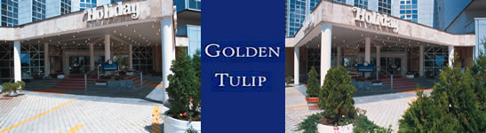

Situated at the western entrance to Zagreb, the Hotel “Golden Tulip Holiday” is the right address offering all adapted facilities needed for you, wherever you come from.

Easy access and large parking area will spare you worries.

LOCAL INFORMATION:
Nearest airport Zagreb-Pleso (international airport) - 20 km, 20 min
Railway station Zagreb, “Glavni kolodvor” - 10 km, 15 min
Zagreb central bus station - 11 km, 20 min

LOCAL MEANS OF PUBLIC TRANSPORT
Local bus station - 250 m
Tramway station - 850 m.

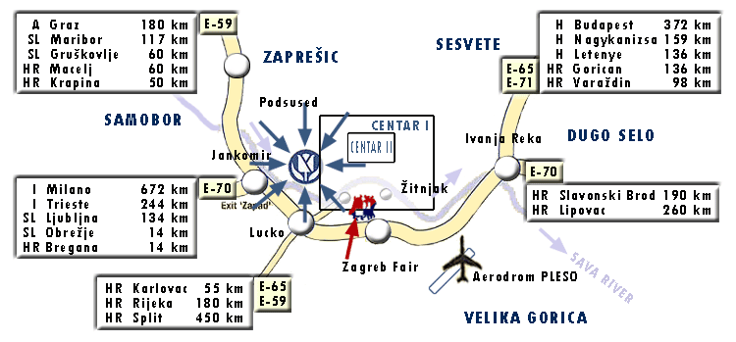

For more information about Croatia and Zagreb, visit:
www.croatia.hr
www.zagreb.hr

