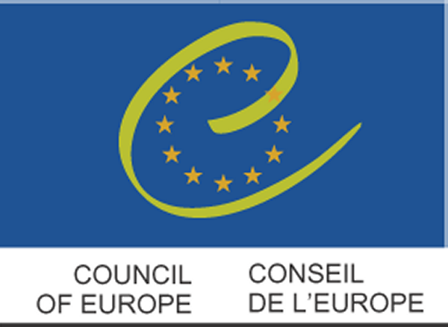


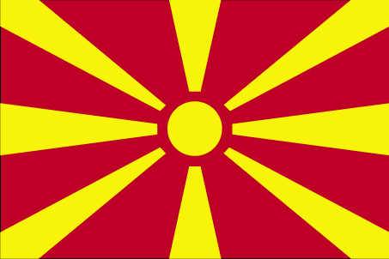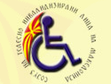

INTERNATIONAL FEDERATION OF PERSONS WITH PHYSICAL DISABILITY - FIMITIC
ASSOCIATION OF PHYSICALLY DISABLED PERSONS OF MACEDONIA – STILM
in cooperation with the
GOVERNMENT OF THE REPUBLIC OF MACEDONIA
under the auspices of the
SECRETARY GENERAL OF THE COUNCIL OF EUROPE,
MR TERRY DAVIS

SEMINAR
«ADVANCING DISABILITY RIGHTS IN EUROPE:
PEOPLE WITH PHYSICAL DISABILITY IN THE COUNTRIES OF SOUTH EASTERN EUROPE »

12th - 15th October 2006
HOTEL «GRANIT » - OHRID –
Former Yugoslav Republic of Macedonia

F I N A L I N V I T A T I O N

AIM OF THE SEMINAR

According to the Statistics there are approximately 30 Million disabled in the European Union. Disabled people are often subject to discrimination. It should be essential that disabled people concerns are included in all discussions when disability issues are on the agenda. This is why FIMITIC in cooperation with its member association STILM is organizing the international Seminar on “Advancing Disability Rights in Europe: People with Physical Disability in the countries of South Eastern Europe“ to demonstrate the factors contributing to the very difficult situation of people with physical disability in the region, inviting speakers who should highlight the present and future challenges and find answers on what tools and methods shall be applied to improve the quality of life of people with disabilities.

The FIMITIC Seminar will cover various fields of life: Accessibility, employment, rehabilitation, health care, social protection as well as national and international regulations should be demonstrated. Identifying problems is very essential but not enough. Alternatives for the solution of the problems are also important to be defined.

Lack of adequate regulations on the specific issues concerning people with disabilities and on their implementation is known. The programs and obligations in this field both on the central administration level and on the level of the member associations need to be reviewed as well. Some factors may be identical in each country but some may vary due to the different economical, social and multicultural as well as historical background. Creating equity of people with physical disabilities needs development of a better understanding of their special situation. To this end the role of disability movement is very important. It is our task to reveal the necessity of establishing legal instruments concerning people with disabilities, other then on citizens without disabilities. We have to stipulate, however the issue requiring special regulation.
The Seminar shall be an exceptional opportunity to get a clearer picture of the position of persons with physical disabilities in South-Eastern Europe aspiring to join the European Union as well as looking into the possibilities of creating a network and cooperation of organizations of persons with physical disabilities in the region. All this in view of encouraging the implementation of the European standards on protection and rights of disabled people in this part of Europe. Apart from this regional approach, the Seminar shall have an international reference by giving a special attention to the Convention on the Rights of Persons with Disabilities which is in the process of adoption within the United Nations.

Proposals will be made by FIMITIC on international and national policies and practices designed to meet the specific needs of people with physical disabilities in the member countries of South-Eastern Europe in order to improve their quality of life.

PROGRAMME

Wednesday, October 11, 2006

Morning - Arrival FIMITIC Board and Preparatory Committee
16.00 hrs - Preparatory Committee meeting

Thursday, October 12, 2006

During day - Arrival of Participants, registration
9.30 hrs - FIMITIC Board meeting
11.00 hrs - Press Conference
18.00 hrs - Preparatory Committee meeting
20.00 hrs - Dinner and first informal get together

Friday, October 13, 2006

08.30 hrs - Registration of Participants
09.30 hrs - Opening Session
Welcome and Addresses
Representatives of Goverment, Parlament and Local
authorities as well as European Institutions
11.00 hrs - Coffee Break
11.30 hrs - Plenary working session
- General Introduction
- Key Presentations
13.00 hrs - Lunch
14.00-16.00 hrs - Plenary working session
17.00 hrs - Ohrid sightseeing tour

20.00 hrs - Dinner

Saturday, October 14, 2006

09.00 hrs - Plenary working session
10.30 hrs - Coffee Break
11.00 hrs - Plenary working session
13.00 hrs - Lunch
15.00 hrs - Discussion
16.30 hrs - Coffee Break
17.00-18.00 hrs - Resolution and Conclusions
20.30 hrs - Final Dinner at the GRANIT hotel

Sunday, October 15, 2006

During day - Departure of Participants

GENERAL INFORMATION

SEMINAR TOPICS:
1. National and international NGO´ s of people with physical disability
and their advocacy work
2. European and worldwide initiatives in the field of disability as human right issue
3. Regional network and cooperation in the member countries of South-Eastern
Europe
4. The way forward: focal point for the development of regional member policies and
support

DEADLINES
* Final papers Key Speakers and Contributions to Seminar: August 31, 2006
* Final registration deadline: September 15, 2006

CONFERENCE LANGUAGES
The official Conference languages will be MACEDONIAN and ENGLISH

CONFERENCE VENUE
Hotel GRANIT St. Stefan
6000 Ohrid
phone: + 389 (0) 46 207 100
fax: + 389 (0) 46 207 141
e-mail: hotel-granit@europe.com
www.hotelgranit.com.mk.
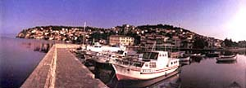
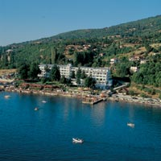
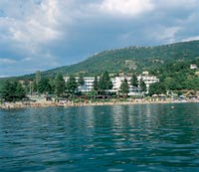

The GRANIT Hotel is located about 7 km outside the city of Ohrid by the Ohrid Lake. The hotel is accessible for persons with physical disabilities including wheelchair sers.

PRICES FOR FULL ACCOMODATION (room and three meals per person/day):

EUR 57,00 – Single room
EUR 49,00 – Double room

REGISTRATION

STILM
Mrs. Biljana Manevska
Sojuz na telesno invalidizirani lica na Makedonija
11 Oktomvri 42-a
1000 Skopje
Republika Makedonija
phone: + 389 (0) 2 32 11 280
fax: + 389 (0) 2 32 11 280
e-mail: anabil@mt.net.mk

INFORMATION / CONTACT ADDRESSES

FIMITIC STILM
Mrs. Marija Stiglic Mrs. Biljana Manevska
Plitterdorfer Str. 103 11 Oktomvri 42-a
D-53173 Bonn 1000 Skopje
Germany Republika Makedonija
phone: + 49 (0) 228 9359 191 phone: + 389 (0) 2 32 11 280
fax: + 49 (0) 228 9359 192 fax: + 389 (0) 2 32 11 280

e-mail: FIMITIC@t-online.de e-mail: anabil@mt.net.mk www.fimitic.org www.stilm.com

ORAL PRESENTATIONS
All presentations must be on slides or CD
Presentations can be brought to the preview room at any time, but at least 2 hours before start of the plenary session.

PROJECTION
The following technical equipement is available for presentation:
- slide projector
- overhead projector
- videoprojector for VHS system
- PC projector

POSTERS AND INFORMATION MATERIAL
In front of the conference hall will be an exibition area with the possibility to set-up posters and desks for other information material.
Your interest to be announced to STILM in right time beforehand.

VISA
Please check on your own in right time if entry visa for FYROMacedonia is required for your country. A list is attached for your attention.

WEATHER
This part of Republic of Macedonia has continental climate. The daily temperature expected in Ohrid in October is around 17º C.

BANKS
– Ohridska banka - is open from Monday to Friday 8.00 to 20.00 hrs., Saturday and Sunday from 8.00 to 12.00 hrs. - Komercijalna banka is open Monday to Friday 8.00 to 20.00 hrs, Saturday from 8.00 to 17.00 hrs, Sunday closed
CURRENCY
The currency in the Republic of Macedonia is the DENAR (MKD). The equivalence of domestic currency and EUR is: 1 EUR approx. 62,2608 MKD.
Payment with credit cards is possible (Diners, Visa, American Express, Euro-card, Mastercard) as well as with Euro-checks and accepted by the hotel.

POST OFFICE
Open from Monday to Friday, working hours are from 8.00 to 20.00 hrs,
and on Saturday from 8.00 to 17.00 hrs.

VOLTAGE
The standard electric current in the Republic of Macedonia is 220 V with a frequency 50 Hz.

TRANSPORT
Clear indications of your exact arriva/departure details are needed with your registration beforehand.
Accessible vans will be made available for wheelchair users and their assistants.
For those travellling by plane to the Skopje airport, local transport to the destination, the GRANIT Hotel in Ohrid (Skopje Airport-Ohrid about 180 km) shall be provided by a taxi company.
Each car can take up to 2 (two) wheelchair users or 1 (one) w/u + 2-3 other non w/u passengers. The cost per car is € 140 for both directions (Skopje-Ohrid-Skopje)
The Ohrid airport is located about 12 km from the GRANIT Hotel.

STILM will have a staff member at the Meeting point Airport Skopje or/and Ohrid to assist participants in arranging for transport.
Taxis are available at any time and the tarif is unique in Ohrid
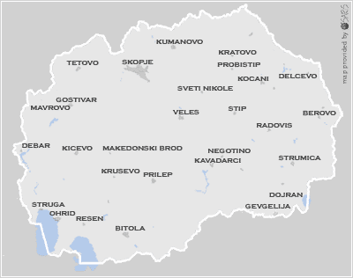
CITY OF OHRID

Map of FYROMacedonia

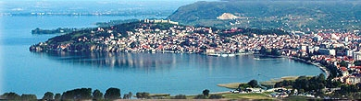

A panoramic view of the town of Ohrid
and the UNESCO world cultural heritage place,
also the place „Where even Angels come for a holiday“

You are also invited to visit the following links:

http://www.ohrid.gov.mk/index.htm
http://www.ohrid.gov.mk/angliska%20verzija/gallery.htm

http://www.ohrid.org.mk/eng/index.htm

